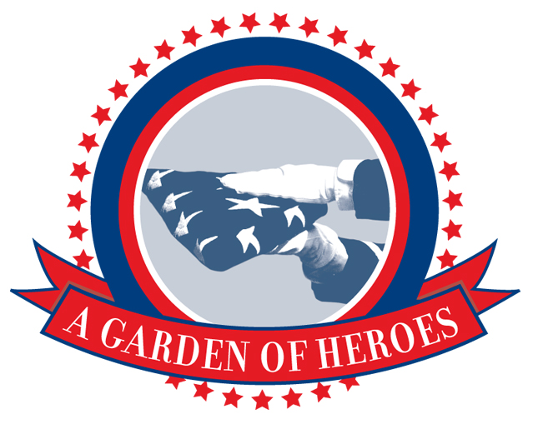
Miramar National Cemetery Support Foundation

November 1, 2018

BRIG. GEN. ROBERT L. CARDENAS, WWII POW,
TO SPEAK AT VETERANS DAY CEREMONY

Service will commemorate 100th anniversary of WWI Armistice in 1918

Retired Air Force Brig. Gen. Robert L. Cardenas, who was held as a Prisoner of War during World War II, will be the guest speaker at a Veterans’ Day ceremony, on Sunday, Nov. 11, at Miramar National Cemetery. This year’s ceremony will commemorate the 100th anniversary of the 1918 Armistice that ended World War I. Veterans, active duty military, family members, and the public are invited to attend. The Miramar National Cemetery Support Foundation sponsors the event.

General Information:
Date: Veterans’ Day, Sunday, Nov. 11, 2017
Time: 3:30 p.m. to 4:30 p.m.
Location: At the foot of the Veterans Tribute Tower & Carillon, north side of Miramar National Cemetery.

Program:
Welcome: Catherine Fiorelli, Foundation President & CEO
Rex Kern, Director, Miramar National Cemetery
Guest Speaker: Brig. Gen. Robert L. Cardenas, USAF Retired

Interviews, Photos:
Brig. Gen Cardenas, Cathy Fiorelli, Rex Kern,
Veterans, family members, active duty. Photos/video
of event, families visiting graves of loved ones.
.
Media Accommodations:

Media Contact: Bill Heard, Public Information Officer
619-757-7788 or whheard@aol.com
Media Packets: An on-line press kit will be available.
Interviews: Assistance provided by Bill Heard.
Media Parking: Available on the street near the Carillon Tower.

-- MORE --

Pg. 2, Veterans Day Memorial Service Media Alert

Directions:

Address: Miramar National Cemetery is located at, 5795
Nobel Dr., San Diego, Calif.

From the north: Traveling south on I-5, bear left and take I-805. After
2.5 miles, take the exit for Miramar Rd/La Jolla
Village Dr. Turn left onto Miramar Road. Turn right
on Nobel Dr. Cemetery entrance will be on the left.

From the south: Traveling north on I-805, take the exit for Nobel Dr.
Turn right on Nobel Dr. and the cemetery entrance is
on the right.
Or, drive north on I-5, exit on Nobel Dr. and follow the
street to the cemetery entrance on the right, just after
passing over I-805.

Event Parking: Free parking for the public will be on cemetery
streets.

# # #

